**A Practical activity Report submitted for Engineering Design**

**Project-II (UTA-014) by**

**Details of students**:

**Submitted to:**

**GROUP NO.:**



**DEPARTMENT OF COMPUTER SCIENCE and ENGINEERING THAPAR**

**INSTITUTE OF ENGINEERING & TECHNOLOGY, (A DEEMED TO BE**

**UNIVERSITY), PATIALA, PUNJAB INDIA.**

**DECLARATION**

We declare that this project report is based on our work carried out during our study in our Engineering-design II Computer Lab under the supervision of MRS. HARLEEN KAUR. We assert that the statements made and conclusions drawn are an outcome of our research work. We further certify that the work contained in this report is original and has been done by us under the general supervision of our supervisor. We have followed the guidelines provided by the University in writing this report.

**ABSTRACT**

The Engineering design Project is a one of its kind Project/Course. In a curriculum of theoretical courses, this Course allows us to implement the theoretical knowledge into real-life applications. The application of Programming and Circuits in real-time applications is all about this Course. In this Course, we are supposed to construct an Arduino Uno-based buggy robot with various sensors. The Arduino Uno circuit can be simulated using Tinkercad. The buggy can be used in multiple modes. It can be operated as a line follower using IR sensors; it can detect obstacles using Ultrasonic sensors and become a remote-controlled device using Zigbee. Arduino programming is very similar to C, and hence with light codes, we can make this buggy work. This makes our job easier and also gives quicker results. We also need to work on the mechanics of buggy as well, which is a new domain of knowledge for electronics and computers students. This project will bring out the creativity of students, and they will learn a lot about robotics.

**TABLE OF CONTENTS:**

**Experiment-1**

a. To draw a schematic circuit diagram of PWM Transmitter for Gantry using Autodesk Eagle software.

b.To design a Printed Circuit Board layout of PWM Transmitter for Gantry using Autodesk Eagle software.

**Experiment-2**

a. To draw a schematic circuit diagram of PWM Receiver for Gantry using Autodesk Eagle software. b. To design a Printed Circuit Board layout of PWM Receiver for Gantry Autodesk Eagle software.

**Experiment-3**

a. To draw a schematic diagram of IR sensor module circuit (which helps Buggy robot to move on a predefined path as a line follower) using Autodesk Eagle software.

b. To design a printed circuit board layout of IR sensor module circuit (which helps Buggy robot to move on a predefined path as a line follower) using Autodesk Eagle software.

**Experiment-4**

Design and testing of IR receiver circuit which can sense the signal of a specific pulse width and able to recognize the corresponding Gantry.

a. To solder IR receiver circuit on a general purpose PCB.

b. To test the combined module of IR transmitter and receiver circuits on Buggy Track with Gantry provision through supervisory control mode for Bronze and silver level.

**Experiment-5**

Design and testing of IR transmitter circuit which generates rectangular pulses of specific pulse width for corresponding Gantry.

a. To solder IR transmitter circuit on a general purpose PCB.

b. To write a Program and upload it on the ATtiny based microcontroller through Arduino boot-loader circuit.

c. To test the output pulses on CRO generated through IR transmitter circuit.

**Experiment-6**

Design and testing of IR sensor module circuit which helps Buggy robot to move on a predefined path as a line follower.

a. To solder IR sensor module circuit on a general purpose PCB.

b. To test the output pulses of IR sensor module on predefined track as path follower.

**EXPERIMENT 1**

**Objective:**

1. To draw a schematic diagram of receiver to receive specified pulse width IR signals from gantries using CAD tool (Eagle).
2. To design a printed circuit board layout of receiver circuit using CAD tool (Eagle).

**Software Used:** Eagle Software

**Components Used:**

|  |  |  |  |
| --- | --- | --- | --- |
| **Sr. No.** | **Name of Components** | **Value** | **Specifications** |
| 1 | Capacitor | 10Pf | Electrolytic Capacitor |
| 2 | Resistor | 1k Ω | Carbon resistor with 5% tolerance |
| 3 | Resistor | 22k Ω | Carbon resistor with 5% tolerance |
| 4 | Resistor | 100k Ω | Carbon resistor with 5% tolerance |
| 5 | Resistor | 120k Ω | Carbon resistor with 5% tolerance |
| 6 | LM311D |  | Voltage Comparator |
| 7 | MBD701 |  | Schottky Diode |
| 8 | 22-23-2031 |  | PCB Header |

**Theory:**

1. **CAPACITOR:** The capacitor is an electric component that has the ability to store energy in the form of electrical charges that creates a potential difference, which is a static voltage, much like a small rechargeable battery. The most basic design of a capacitor consists of two parallel conductors (Metallic plate), separated with a dielectric material.  When a voltage source is attached across the capacitor, the capacitor plate gets charged up. The metallic plate attached to the positive terminal will be positively charged, and the plate attached to the negative terminal will be negatively charged.

Fig 1.1 Various types of Capacitors

1. **RESISTOR:** The term "resistor" refers to a device that acts as a two-terminal passive electrical component that is used to limit or regulate the flow of electric current in electrical circuits. And it also allows us to introduce a controlled amount of resistance into an electrical circuit. The most important and commonly used components in an electronic circuit are resistors. A resistor's main job is to reduce current flow and lower voltage in a specific section of the circuit. It's made up of copper wires that are wrapped around a ceramic rod and coated with insulating paint.

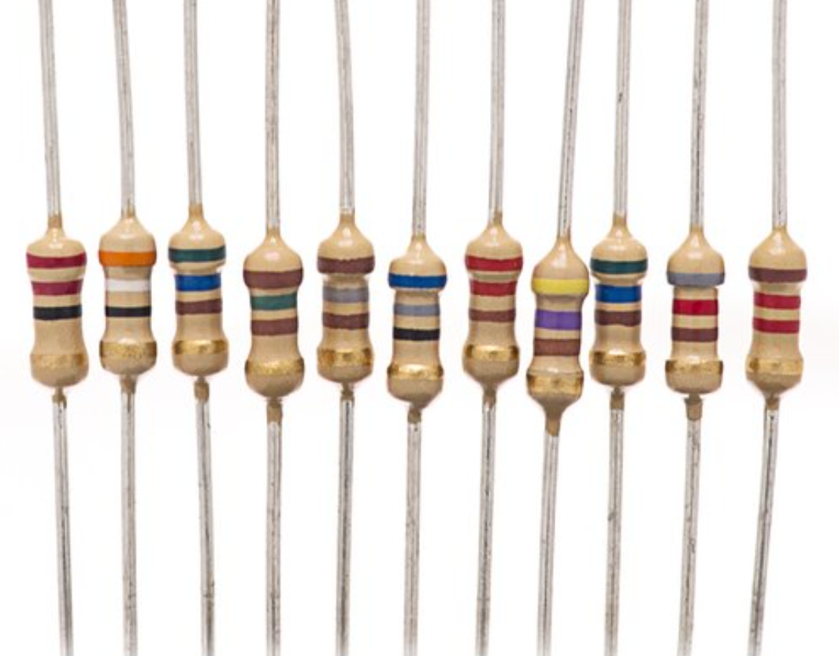

Fig. 1.2 Various Types of Resistors

1. **LM311D:** **It** is a voltage comparator with high speed. It is able to perform tasks over a large range of voltages. Its output levels are compatible with MOS circuits. Relays and lamps can be controlled by LM 311 when it is operating at 50V and 50mA as well. LM-311 has a lot of features like low power consumption, wide operating voltages, strobe capability, maximum input response time.

Fig. 1.3 LM311D

1. **MBD701:** The Schottky diode is a type of metal – semiconductor junction diode, which is also known as hot-carrier diode, low voltage diode or Schottky barrier diode. The Schottky diode is formed by the junction of a semiconductor with a metal. Schottky diode offers fast switching action and has a low forward voltage drop. In a Schottky diode metals like Platinum or Aluminium are used instead of P type semiconductors.

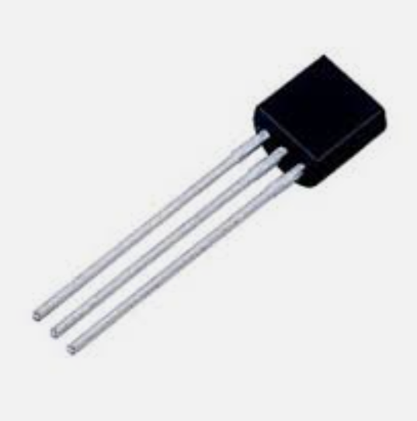

Fig 1.4 MBD701

1. **22-23-2031:** Pin header connectors comprise several different means of connection. Generally, one side is a series of pins which are soldered to a PCB, and they can either be at a right-angle to the PCB surface (usually called "straight") or parallel to the board's surface (confusingly referred to as "right-angle" pins). Such connectors come in a variety of pitches, and may have any number of individual rows of pins. The most commonly seen pin headers are 0.1" (2.54mm) single or double row connectors. This is a [standard breadboard](https://learn.sparkfun.com/tutorials/how-to-use-a-breadboard/all) compatible pitch. These come in [male](https://www.sparkfun.com/products/116) and [female](https://www.sparkfun.com/products/115) versions, and are the connectors used to connect Arduino boards and shields together. Users can easily connect jumper wires to breadboards.

Fig 1.5 22-23-2031

**Schematic Diagram**

Fig 1.6 Schematic Diagram of Receiver Circuit

**Printed Circuit Board Layout:**

Fig 1.7 PCB Layout of Receiver Circuit

**Discussion**

In this experiment, we learnt how to create a receiver on Eagle Software using resistors, capacitor, LM311D, MBD701, and 22-23-2031. We were introduced to various new components and how they work. We can now apply this knowledge to create a receiver circuit for our Buggy Project.

**EXPERIMENT 2**

**Objective:**

a. To draw a schematic circuit diagram of PWM Transmitter for Gantry using Autodesk Eagle software.

b. To design a Printed Circuit Board layout of PWM Transmitter for Gantry using Autodesk Eagle software.

**Software Used:** Eagle Software

**Components Used:**

|  |  |  |  |
| --- | --- | --- | --- |
| **Sr. No.** | **Name of Components** | **Value** | **Specifications** |
| **1** | Capacitor | 10Pf | Electrolytic Capacitor |
| **2** | Capacitor | 10Uf | Electrolytic Capacitor |
| **3** | Resistor | 300 Ω | Carbon resistor with 5% tolerance |
| **4** | LED |  |  |
| **5** | 22-23-2031 |  | PCB Header |
| **6** | DCJ0202 |  | DC Power Jack |
| **7** | 78l05z |  | Voltage Regulator |

**Theory:**

1. **CAPACITOR:** The capacitor is an electric component that has the ability to store energy in the form of electrical charges that creates a potential difference, which is a static voltage, much like a small rechargeable battery. The most basic design of a capacitor consists of two parallel conductors (Metallic plate), separated with a dielectric material.  When a voltage source is attached across the capacitor, the capacitor plate gets charged up. The metallic plate attached to the positive terminal will be positively charged, and the plate attached to the negative terminal will be negatively charged.

Fig 2.1 Various types of Capacitors

1. **RESISTOR:** The term "resistor" refers to a device that acts as a two-terminal passive electrical component that is used to limit or regulate the flow of electric current in electrical circuits. And it also allows us to introduce a controlled amount of resistance into an electrical circuit. The most important and commonly used components in an electronic circuit are resistors. A resistor's main job is to reduce current flow and lower voltage in a specific section of the circuit. It's made up of copper wires that are wrapped around a ceramic rod and coated with insulating paint.



Fig. 2.2 Various Types of Resistors

1. **22-23-2031:** Pin header connectors comprise several different means of connection. Generally, one side is a series of pins which are soldered to a PCB, and they can either be at a right-angle to the PCB surface (usually called "straight") or parallel to the board's surface (confusingly referred to as "right-angle" pins). Such connectors come in a variety of pitches and may have any number of individual rows of pins. The most seen pin headers are 0.1" (2.54mm) single or double row connectors. This is a [standard breadboard](https://learn.sparkfun.com/tutorials/how-to-use-a-breadboard/all) compatible pitch. These come in [male](https://www.sparkfun.com/products/116) and [female](https://www.sparkfun.com/products/115) versions, and are the connectors used to connect Arduino boards and shields together. Users can easily connect jumper wires to breadboards.

Fig 2.3 22-23-2031

1. **LED:** A light-emitting diode (LED) is a [semiconductor](https://en.wikipedia.org/wiki/Semiconductor) [light source](https://en.wikipedia.org/wiki/Light_source) that emits light when [current](https://en.wikipedia.org/wiki/Electric_current) flows through it. [Electrons](https://en.wikipedia.org/wiki/Electron) in the semiconductor recombine with [electron holes](https://en.wikipedia.org/wiki/Electron_hole), releasing energy in the form of [photons](https://en.wikipedia.org/wiki/Photon). The colour of the light (corresponding to the energy of the photons) is determined by the energy required for electrons to cross the [band gap](https://en.wikipedia.org/wiki/Band_gap) of the semiconductor. White light is obtained by using multiple semiconductors or a layer of light-emitting [phosphor](https://en.wikipedia.org/wiki/Phosphor) on the semiconductor device.

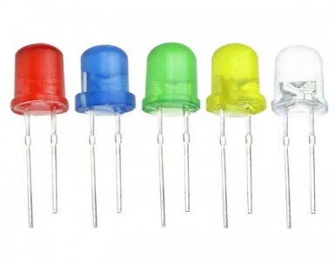

Fig 2.4 LEDs

1. **DCJ0202:** A DC connector (or DC plug, for one common type of connector an [electrical connector](https://en.wikipedia.org/wiki/Electrical_connector) for supplying [direct current](https://en.wikipedia.org/wiki/Direct_current) (DC) power. The intended use of these plugs is on the cable connected to an external [AC adapter](https://en.wikipedia.org/wiki/AC_adapter) ([power supply](https://en.wikipedia.org/wiki/Power_supply)). The matching jack or socket is permanently fitted to the equipment to be powered. Some of these jacks contain a normally closed contact, which can be used to disconnect internal batteries whenever the power supply is connected, avoiding the risk of battery leakage or explosion posed by incorrect recharging of the batteries.

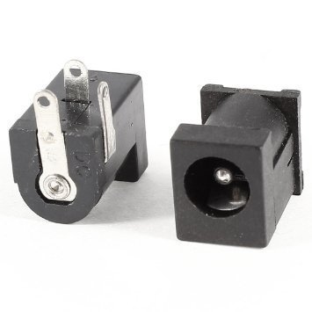

Fig 2.5 DCJ0202

1. **78l05z: Voltage regulators**are very common in electronic circuits. They provide a constant output voltage for a varied input voltage. In our case the 78L05 IC is an iconic regulator IC that finds its application in most of the projects. The name 78L05 signifies two meaning, “78” means that it is a positive voltage regulator and “05” means that it provides 5V as output. So, our 7805 will provide a +5V output voltage.

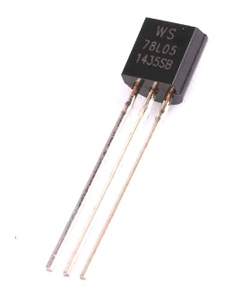

Fig 2.6 78l05z

**Schematic Diagram**

Fig 2.6 Schematic Diagram of Receiver Circuit

**Printed Circuit Board Layout:**

Fig 2.7 PCB Layout of Receiver Circuit

**Discussion**

In this experiment, we learnt how to create a transmitter on Eagle Software. We were introduced to various new components and how they work. We can now apply this knowledge to create a receiver circuit for our Buggy Project.

**EXPERIMENT 3**

**Objective:**

1. To draw a schematic diagram of IR sensor module circuit (which helps Buggy robot to move on a predefined path as a line follower) using Autodesk Eagle software.
2. To design a printed circuit board layout of IR sensor module circuit (which helps Buggy robot to move on a predefined path as a line follower) using Autodesk Eagle software.

**Software Used:** Eagle Software

**Components Used:**

|  |  |  |  |
| --- | --- | --- | --- |
| **Sr. No.** | **Name of Components** | **Value** | **Specifications** |
| **1** | lmv358mm |  | Operational Amplifier |
| **2** | sfh482 |  | IR LED |
| **3** | bpx65 |  | Photodiode |
| **4** | Resistor | 10k | Carbon resistor with 5% tolerance |
| **5** | Resistor | 330ohm | Carbon resistor with 5% tolerance |
| **6** | Potentiometer | 10k |  |
| **7** | Led3mm |  |  |
| **8** | Mta02-100 |  | AMP Connector |

**Theory:**

1. **RESISTOR:** The term "resistor" refers to a device that acts as a two-terminal passive electrical component that is used to limit or regulate the flow of electric current in electrical circuits. And it also allows us to introduce a controlled amount of resistance into an electrical circuit. The most important and commonly used components in an electronic circuit are resistors. A resistor's main job is to reduce current flow and lower voltage in a specific section of the circuit. It's made up of copper wires that are wrapped around a ceramic rod and coated with insulating paint.



Fig. 3.1 Various Types of Resistors

1. **LMV358MM:** An operational amplifier is an integrated circuit that can amplify weak electric signals. An operational amplifier has two input pins and one output pin. Its basic role is to amplify and output the voltage difference between the two input pins.

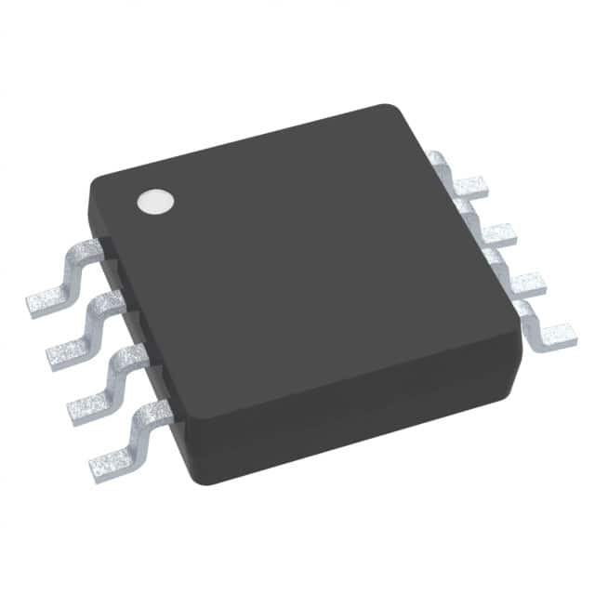

Fig. 3.2 LMV358MM

1. **SFH482:** An IR LED (infrared light emitting diode) is a solid state lighting (SSL) device that emits light in the infrared range of the electromagnetic radiation spectrum. IR LEDs allow for cheap, efficient production of infrared light, which is electromagnetic radiation in the 700 nm to 1mm range. IR LEDs are useful in a number of types of electronics, including many types of remote controls for televisions and other electronics. Used with infrared cameras, IR LEDs can act like a spot light while remaining invisible to the naked eye.

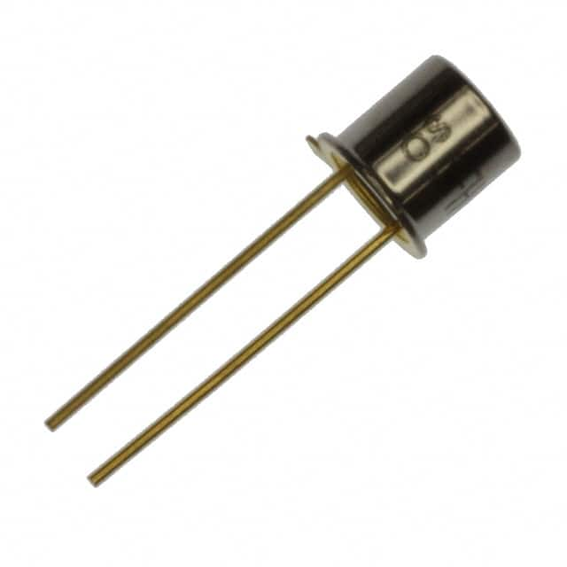

Fig 3.3 SFH482

1. **BPX65:** A photodiode is a semiconductor device with a P-N junction that converts photons (or light) into electrical current. The P layer has an abundance of holes (positive), and the N layer has an abundance of electrons (negative).

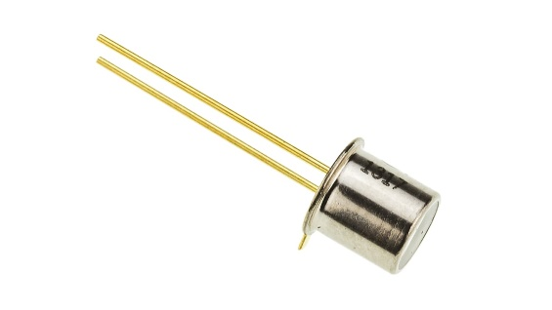

Fig 3.4 BPX65

1. **POTENTIOMETER:** A potentiometer is a three-terminal resistor with a sliding or rotating contact that forms an adjustable voltage divider. If only two terminals are used, one end and the wiper, it acts as a variable resistor or rheostat.

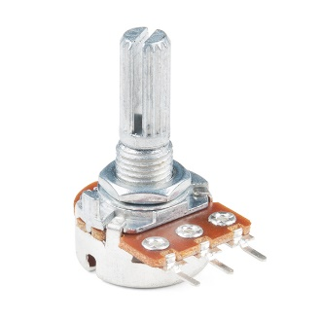

Fig. 3.5 Potentiometer

1. **LED3MM:** A light-emitting diode (LED) is a [semiconductor](https://en.wikipedia.org/wiki/Semiconductor) [light source](https://en.wikipedia.org/wiki/Light_source) that emits light when [current](https://en.wikipedia.org/wiki/Electric_current) flows through it. [Electrons](https://en.wikipedia.org/wiki/Electron) in the semiconductor recombine with [electron holes](https://en.wikipedia.org/wiki/Electron_hole), releasing energy in the form of [photons](https://en.wikipedia.org/wiki/Photon). The colour of the light (corresponding to the energy of the photons) is determined by the energy required for electrons to cross the [band gap](https://en.wikipedia.org/wiki/Band_gap) of the semiconductor. White light is obtained by using multiple semiconductors or a layer of light-emitting [phosphor](https://en.wikipedia.org/wiki/Phosphor) on the semiconductor device.

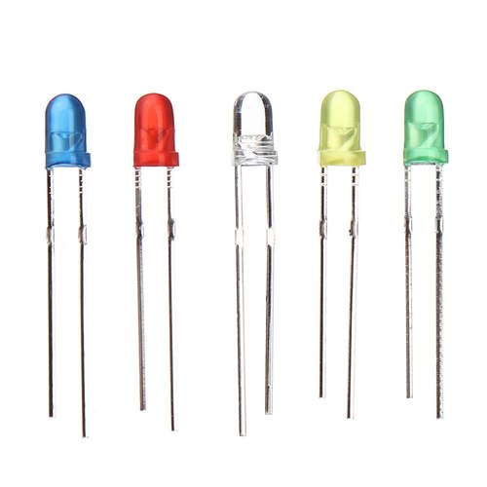

Fig. 3.6 LED3MM

1. **MTA02-100:** Amp Connectors Amp connectors, or Amphenol connectors, is a distinctive connector commonly used in various areas of electrical engineering. Amp connectors vary in amperage (the strength of an electric current), which determines their application.

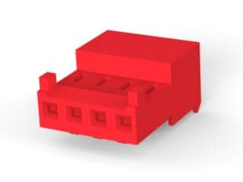

Fig. 3.7 MTA02-100

**Schematic Diagram**

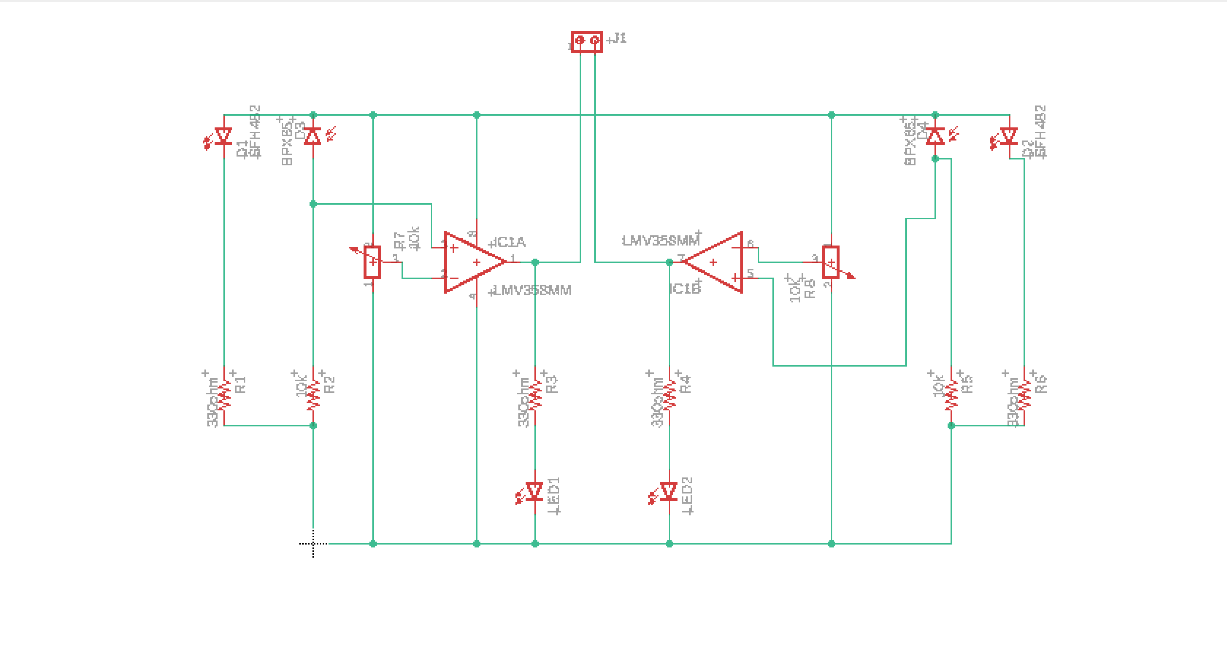

Fig 3.8 Schematic Diagram of IR Sensor Module

**Printed Circuit Board Layout:**

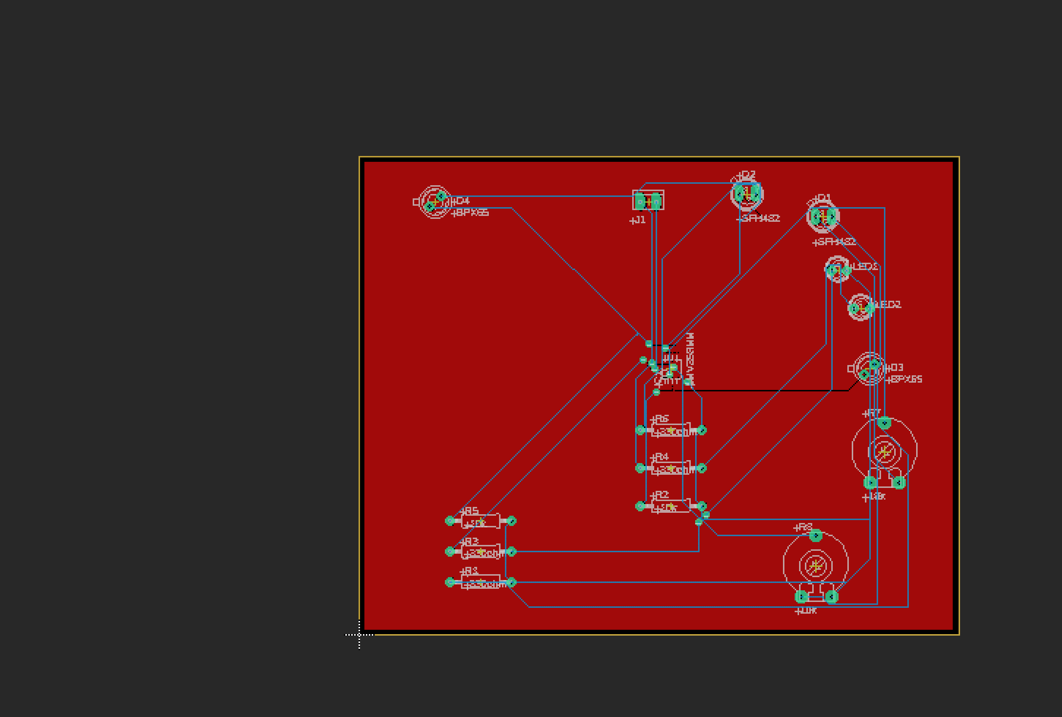

Fig 3.9 PCB Layout of IR Sensor Module

**Discussion**

In this experiment, we learnt how to create a IR Sensor circuit on Eagle Software using. We were introduced to various new components and how they work. We can now apply this knowledge to create a receiver circuit for our Buggy Project.

# Experiment-4

**Objective:**

# Design and testing of IR receiver circuit which can sense the signal of a specific pulse width and able to recognize the corresponding Gantry.

# a. To solder IR receiver circuit on a general purpose PCB.

# b. To test the combined module of IR transmitter and receiver circuits on Buggy Track with Gantry provision through supervisory control mode for Bronze and silver level.

# Component Used:

|  |  |  |  |
| --- | --- | --- | --- |
| **Sr. No** | **Name of Components** | **Value** | **Specifications** |
| 1. | Resistor | 120K Ω | Carbon Resistor with 5% |
| Tolerance |
| 2. | Resistor | 100KΩ | Carbon Resistor with 5% |
| Tolerance |
| 3. | Resistor | 22 KΩ | Carbon Resistor with 5% |
| Tolerance |
| 4. | Resistor | 1 KΩ | Carbon Resistor with 5% |
| Tolerance |
| 5. | Capacitor | 100nF | Ceramic Capacitor |
| 6. | LM311D |  | Voltage Comparator |
| 7. | MBD701 |  | Schottky diode |

**Table 4.1** List of components used

# Theory:

This circuit receives the signal and the voltage comparator analyses the signal to either carry forward the current or to cut the supply to the further circuit. The diode used is for faster operation of the circuit as this diode has fast switching speeds. We also the use of PCB headers and how it helps connect different components on to one circuit board.

**Components used for soldering:**

**1.Solder Iron**

A soldering iron is a **hand tool used to heat solder**, usually from an electrical supply at high temperatures above the melting point of the metal alloy. This allows for the solder to flow between the workpieces needing to be joined.

**2.Solder wire**

Solder wires are wires with a low melting point which can melt along with the soldering iron. Depending on the application and soldering temperature, many different types of soldering wires are available.

Solder wires are generally two different types - lead alloy solder wire and lead-free solder.

**3.Connecting wires**

**4.Wire Cutter**

**5. Suction Pump**

Vaccum pump for desoldering.

# Schematic Diagram:

# 

**Working of circuit:**

Receiver circuit is placed on buggy which receives the IR pulses from gantry. We use voltage comparator to compare the two voltages and give the desired output. At first when the buggy is not under the gantry, the diode is reverse bias, acting as an open circuit, therefore forcing the current to go through the R1 resistor and thus give a HIGH on inverting input of the voltage 15 comparator. But when infrared light falls on the diode form the transmitter connected to a gantry, then the depletion layer starts diminishing, thus allowing the current to go through the least restricted path and give a high on the non-inverting input of the voltage comparator.

**Challenges while soldering:**

1. Cold joint
2. Disturbed joint
3. Overheated joint
4. Insufficient wetting of the surface mount
5. Insufficient wetting of the pad
6. Insufficient wetting of the pin
7. Solder starved
8. Too much solder
9. Untrimmed leads

**Circuit images:**

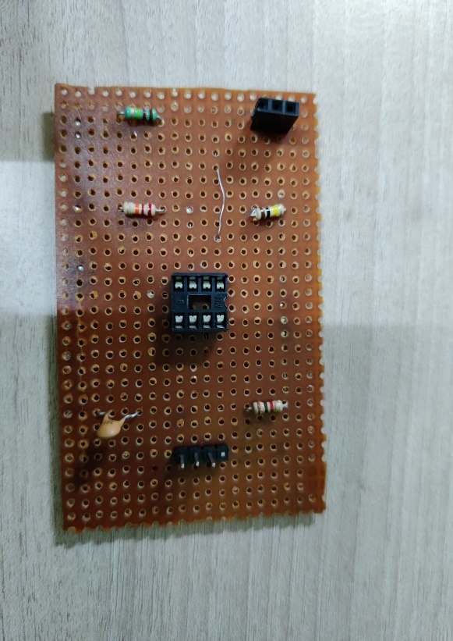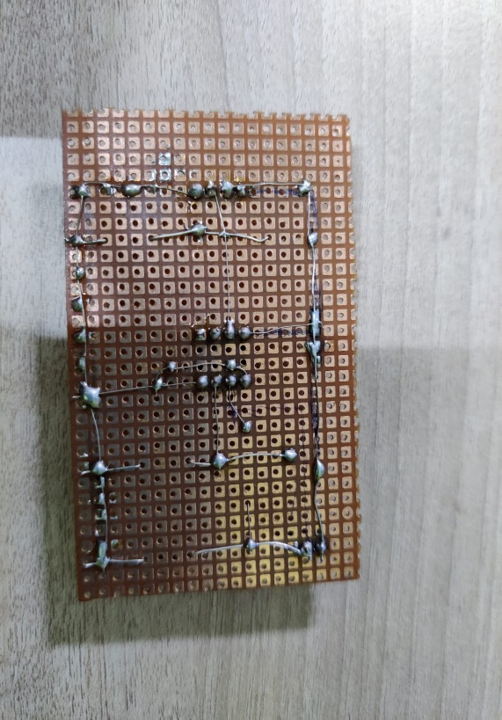

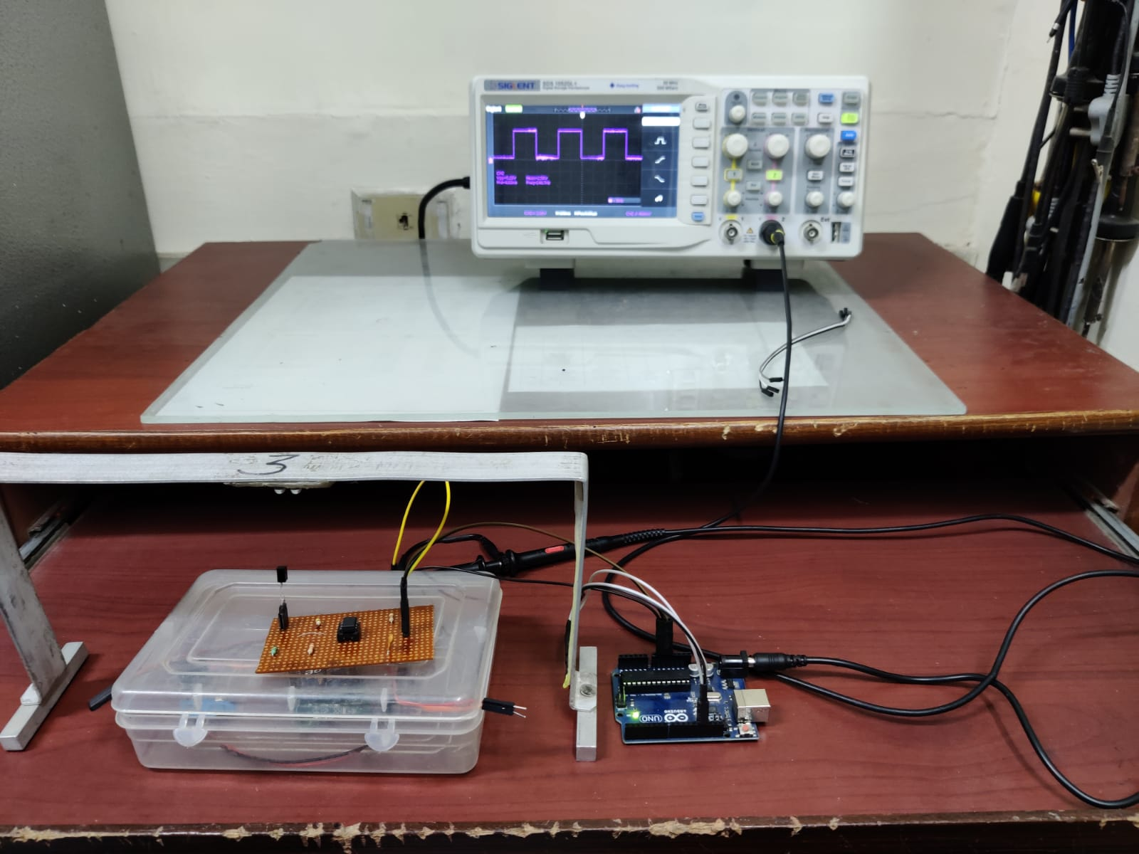

**Conclusion:**

In this experiment I learned to construct a receiver circuit by soldering on a PCB board.

# Experiment-5

**Objective:**

Design and testing of IR transmitter circuit which generates rectangular pulses of specific pulse width for corresponding Gantry.

a. To solder IR transmitter circuit on a general purpose PCB.

b. To write a Program and upload it on the ATtiny based microcontroller through Arduino boot-loader circuit.

c. To test the output pulses on CRO generated through IR transmitter circuit.

# Components Used:

|  |  |  |  |
| --- | --- | --- | --- |
| **Sr. No** | **Name of Components** | **Value** | **Specifications** |
| 1. | Resistor | 220 Ω | Carbon Resistor with 5% Tolerance |
| 2. | Capacitor | 1000nF | Electrolytic Capacitor |
| 3. | Capacitor | 10nF | Electrolytic Capacitor |
| 4. | DCJ0202 |  | DC Power Jack |
| 5. | HLMP6 | 5V | Dome Lamp |
| 6. | IC 78L05Z | +5V | Positive Voltage Regulator |
| 7. | 22-23-2031 |  | PCB Header |
| 8. | PIC12F629 |  | Microcontroller |

# Theory:

This is a pulse width modulation (PWM) based transmitter circuit for generating specified pulse width waveforms for gantries placed at different locations on the path.

**Components used for soldering:**

**1.Solder Iron**

A soldering iron is a **hand tool used to heat solder**, usually from an electrical supply at high temperatures above the melting point of the metal alloy. This allows for the solder to flow between the workpieces needing to be joined.

**2.Solder wire**

Solder wires are wires with a low melting point which can melt along with the soldering iron. Depending on the application and soldering temperature, many different types of soldering wires are available.

Solder wires are generally two different types - lead alloy solder wire and lead-free solder.

**3.Connecting wires**

**4.Wire Cutter**

**5. Suction Pump**

Vaccum pump for desoldering.

# Schematic Diagram:

# 

**Working of circuit:**

Receiver circuit is placed on buggy which transmits

**Challenges while soldering:**

1. Cold joint
2. Disturbed joint
3. Overheated joint
4. Insufficient wetting of the surface mount
5. Insufficient wetting of the pad
6. Insufficient wetting of the pin
7. Solder starved
8. Too much solder
9. Untrimmed leads

**Circuit images:**

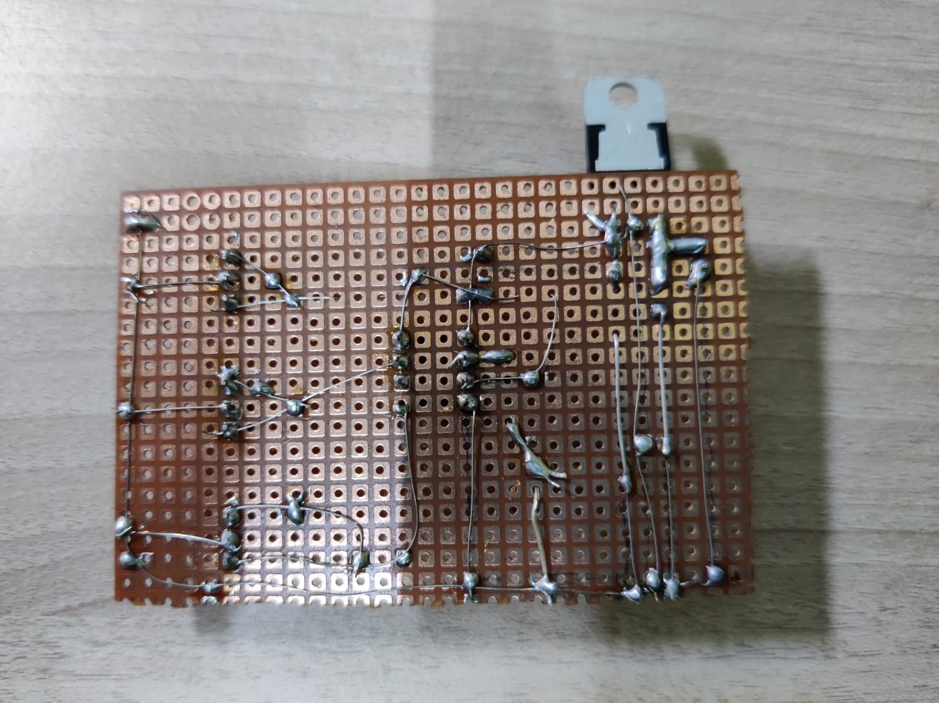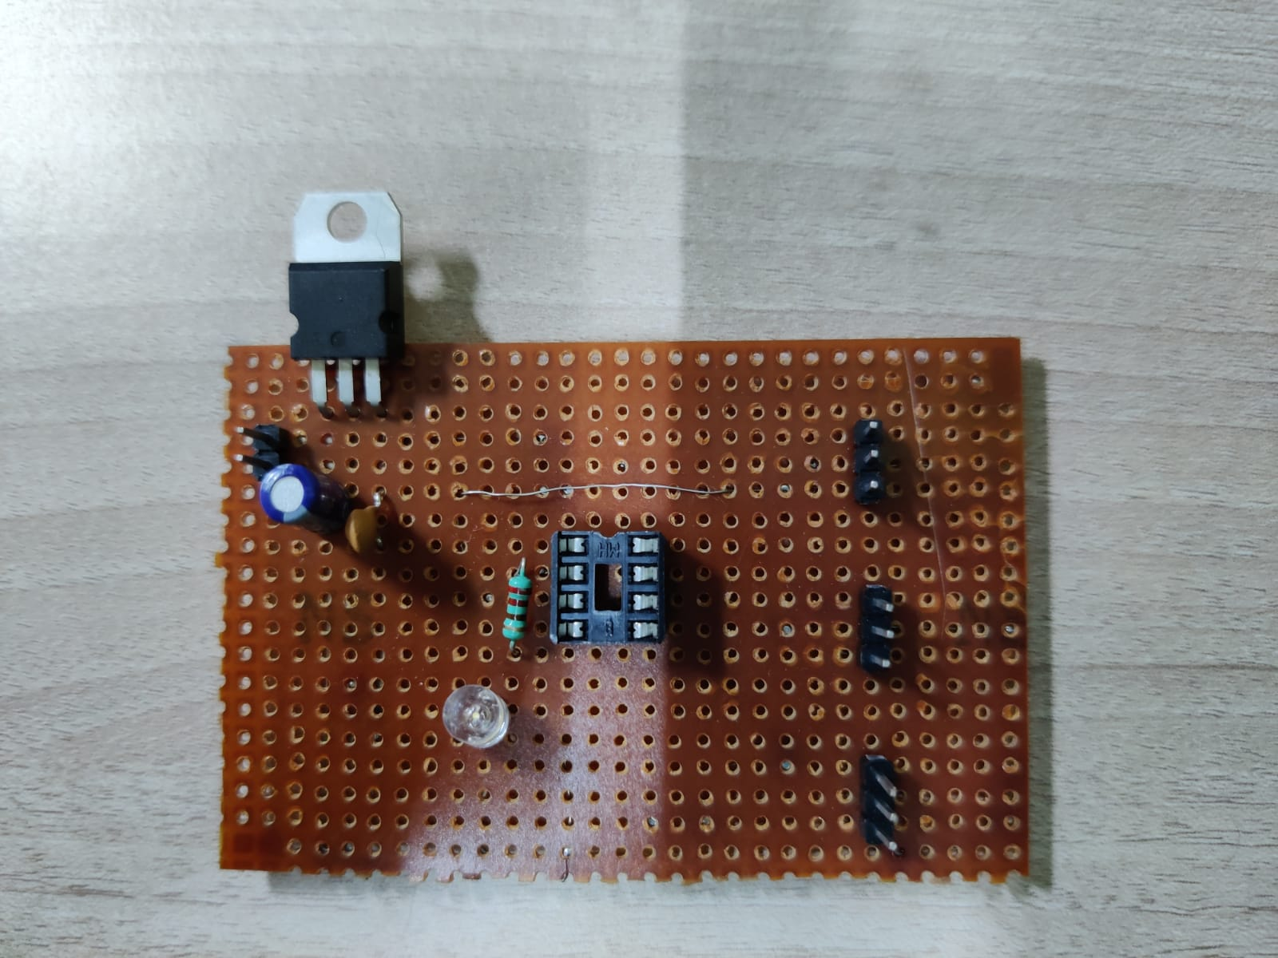

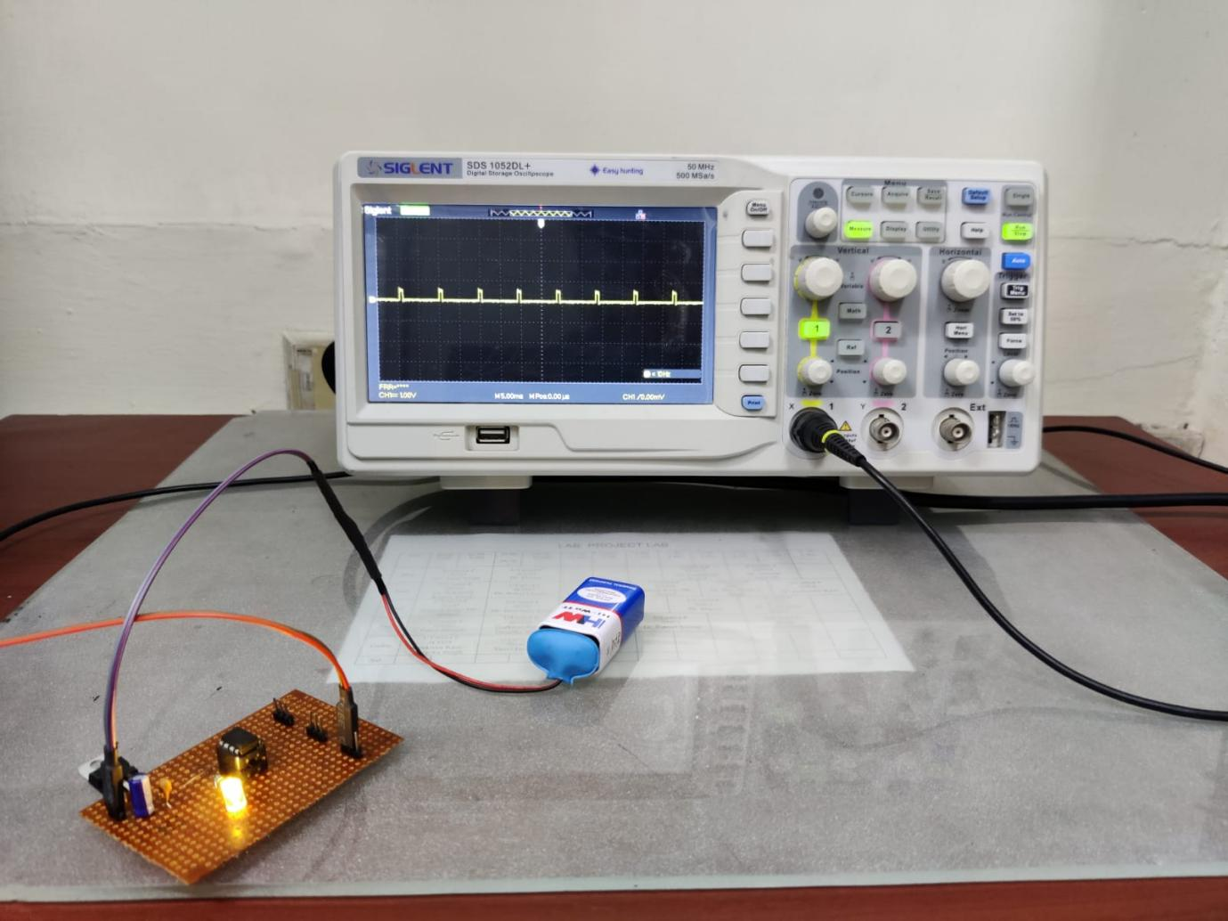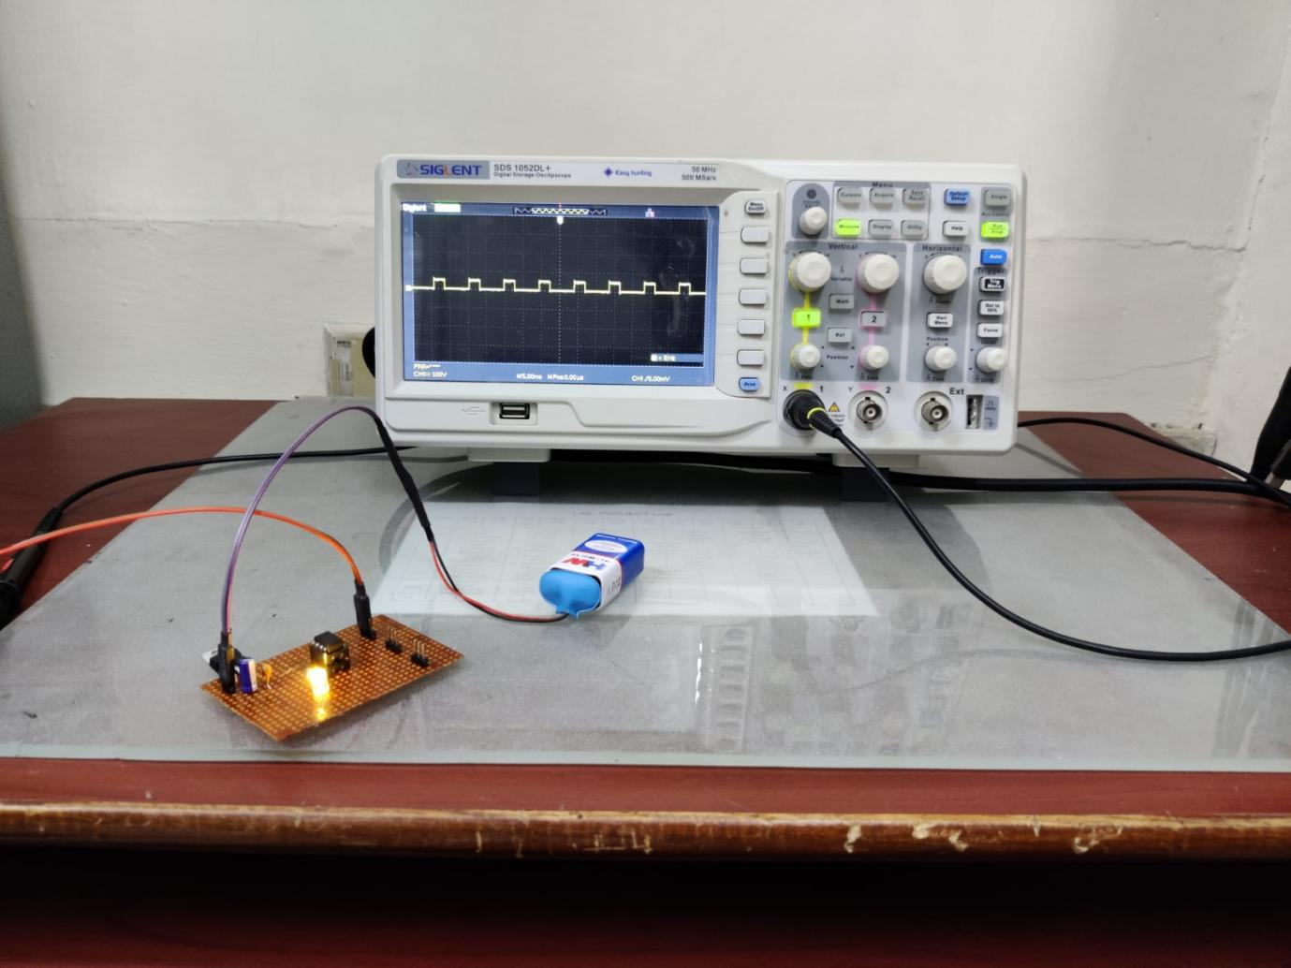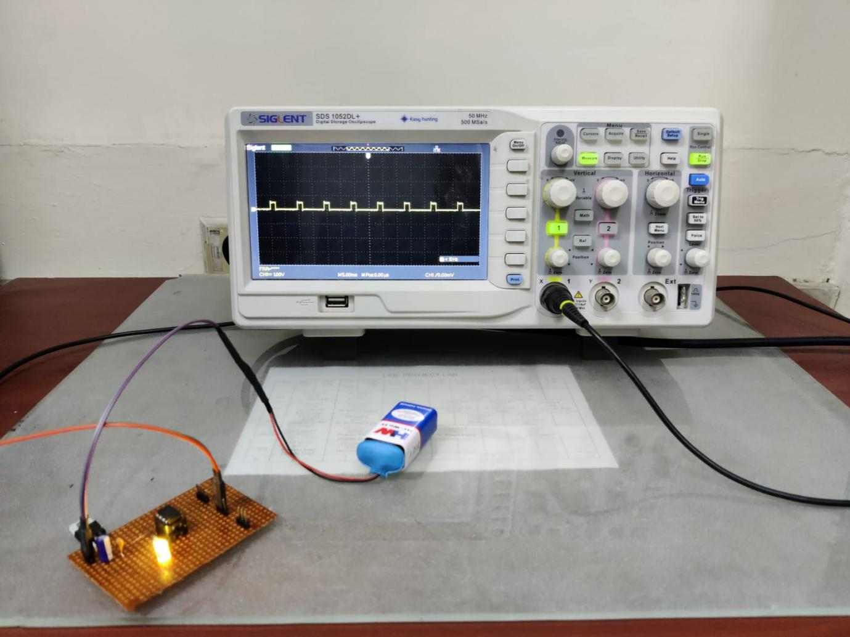

**Conclusion:**

In this experiment I learned to construct a transmitter circuit by soldering on a PCB board.

# Experiment-6

**Objective:**

# Design and testing of IR receiver circuit which can sense the signal of a specific pulse width and able to recognize the corresponding Gantry.

# a. To solder IR receiver circuit on a general purpose PCB.

# b. To test the combined module of IR transmitter and receiver circuits on Buggy Track with Gantry provision through supervisory control mode for Bronze and silver level.

# Component Used:

|  |  |  |  |
| --- | --- | --- | --- |
| **Sr. No.** | **Name of Components** | **Value** | **Specifications** |
| **1** | lmv358mm |  | Operational Amplifier |
| **2** | sfh482 |  | IR LED |
| **3** | bpx65 |  | Photodiode |
| **4** | Resistor | 10k | Carbon resistor with 5% tolerance |
| **5** | Resistor | 330ohm | Carbon resistor with 5% tolerance |
| **6** | Potentiometer | 10k |  |
| **7** | Led3mm |  |  |
| **8** | Mta02-100 |  | AMP Connector |

# Theory:

This is a pulse width modulation (PWM) based transmitter circuit for generating specified pulse width waveforms for gantries placed at different locations on the path.

**Components used for soldering:**

**1.Solder Iron**

A soldering iron is a **hand tool used to heat solder**, usually from an electrical supply at high temperatures above the melting point of the metal alloy. This allows for the solder to flow between the workpieces needing to be joined.

**2.Solder wire**

Solder wires are wires with a low melting point which can melt along with the soldering iron. Depending on the application and soldering temperature, many different types of soldering wires are available.

Solder wires are generally two different types - lead alloy solder wire and lead-free solder.

**3.Connecting wires**

**4.Wire Cutter**

**5. Suction Pump**

Vaccum pump for desoldering.

# Schematic Diagram:

# 

**Working:**

IR Sensor circuit is responsible for movement of buggy along the black path. It contains 2 IR sensor pairs consisting IR transmitter which emits IR light and IR receiver which receives the light. Light falling on the white surface is reflected back and is received by the IR receiver and the circuit is in ON state and helps buggy move but when the light falls on the black surface, it is absorbed and the receiver does not receive the light and at that time the pair is in OFF state which stops the particular wheel, it basically allows correct movement of buggy on right or left turns.

**Challenges while soldering:**

1. Cold joint
2. Disturbed joint
3. Overheated joint
4. Insufficient wetting of the surface mount
5. Insufficient wetting of the pad
6. Insufficient wetting of the pin
7. Solder starved
8. Too much solder
9. Untrimmed leads

**Circuit images:**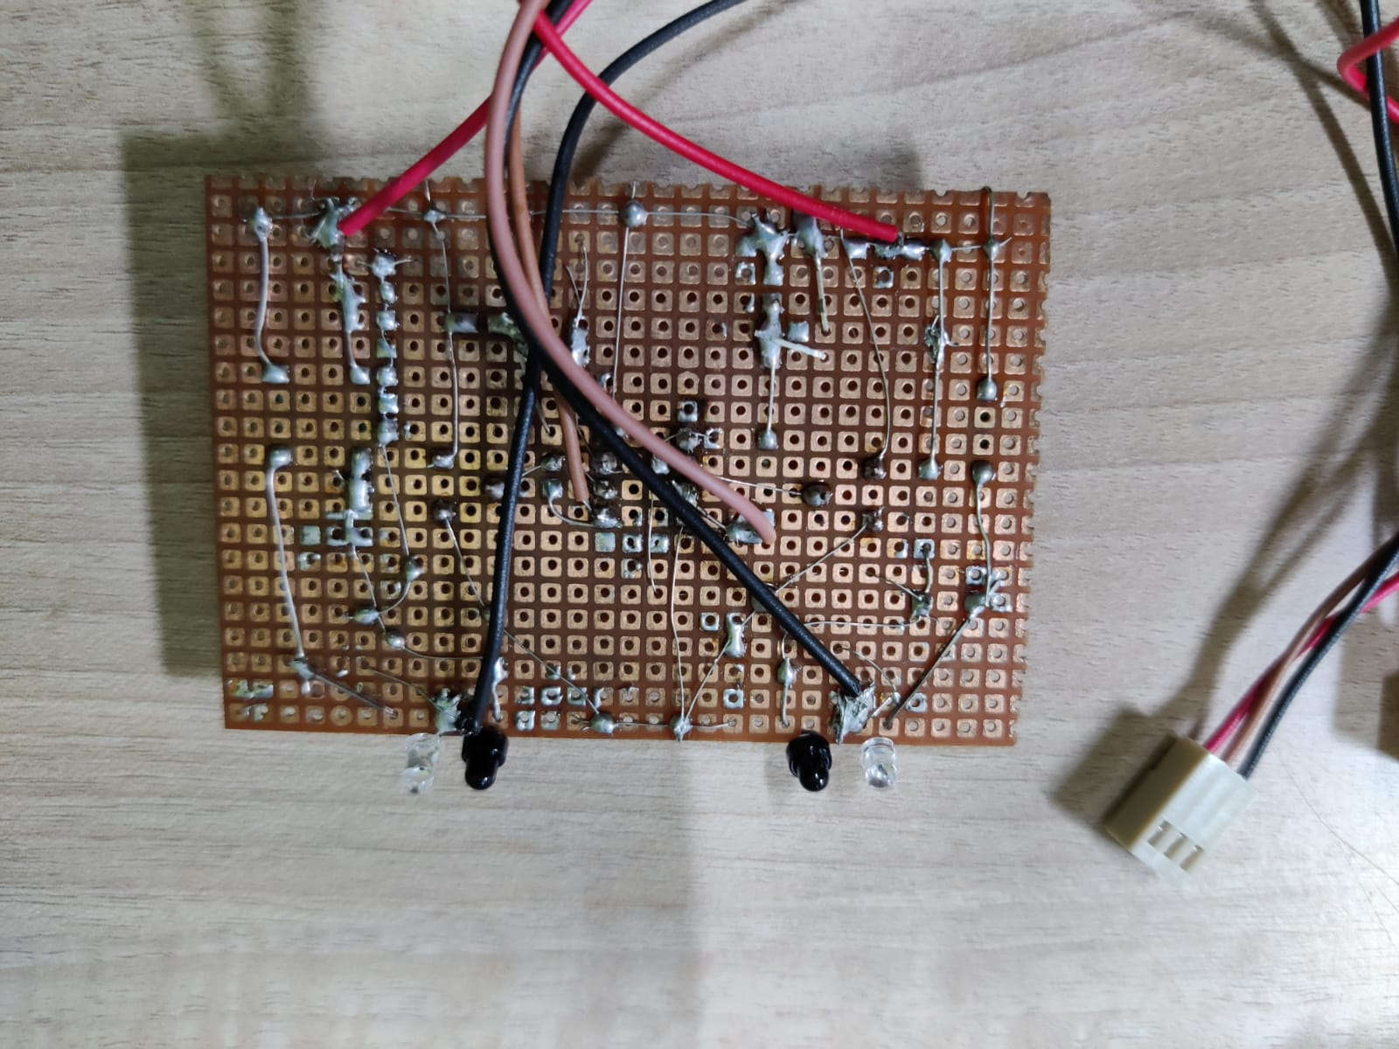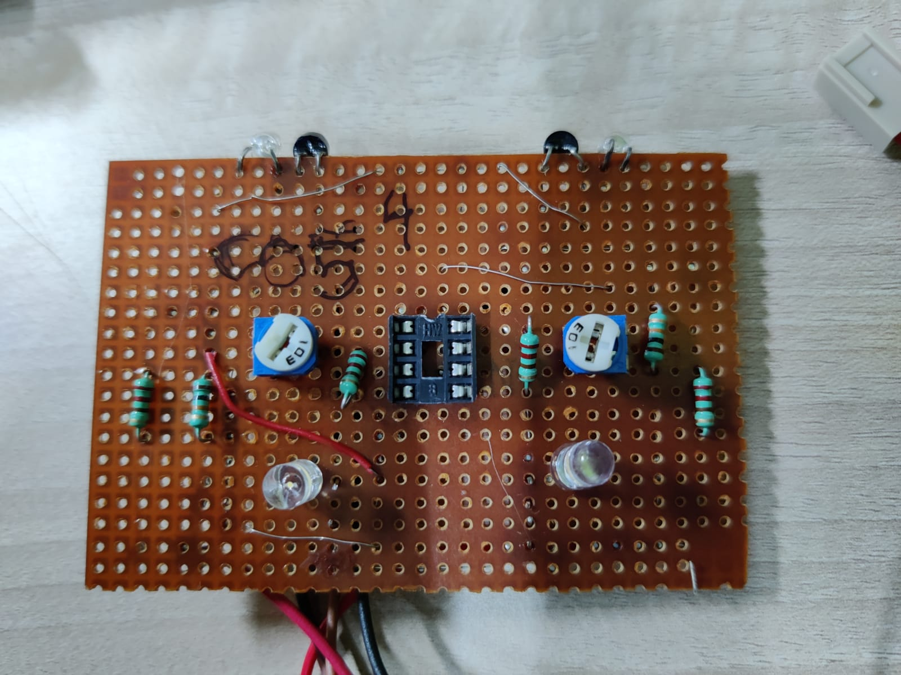

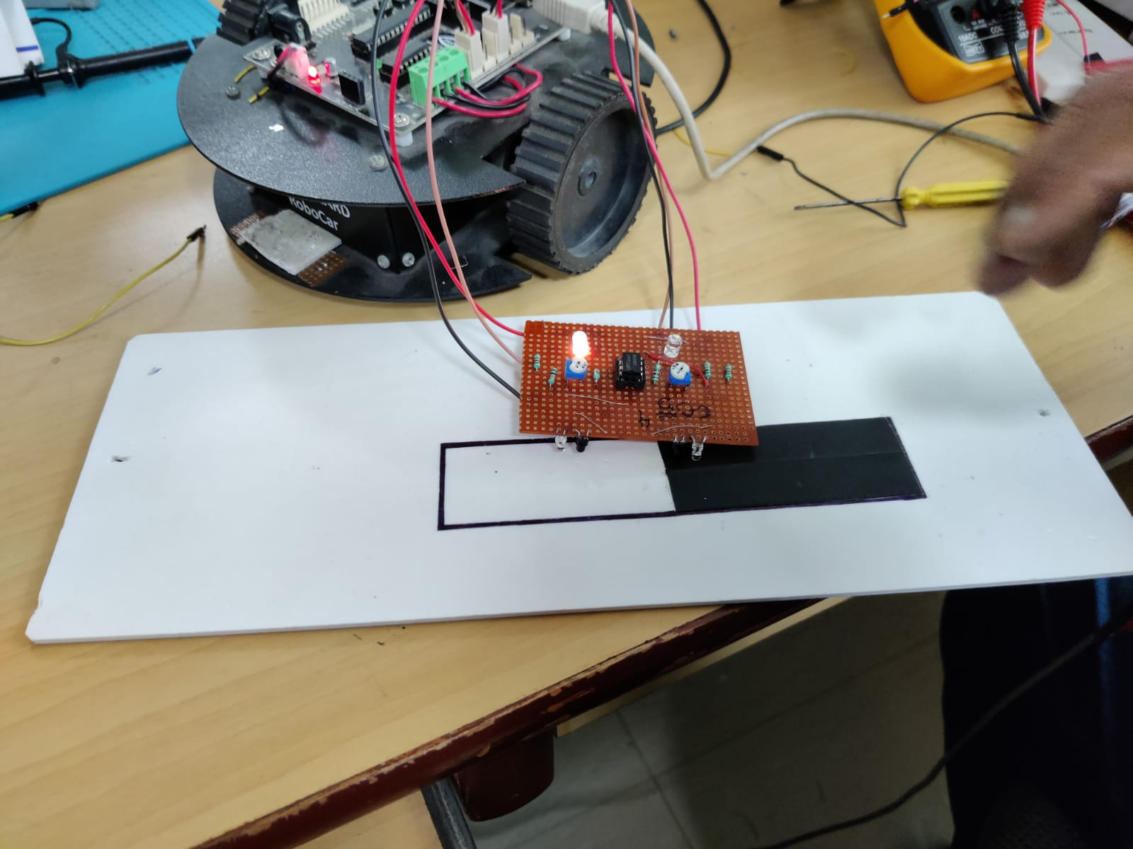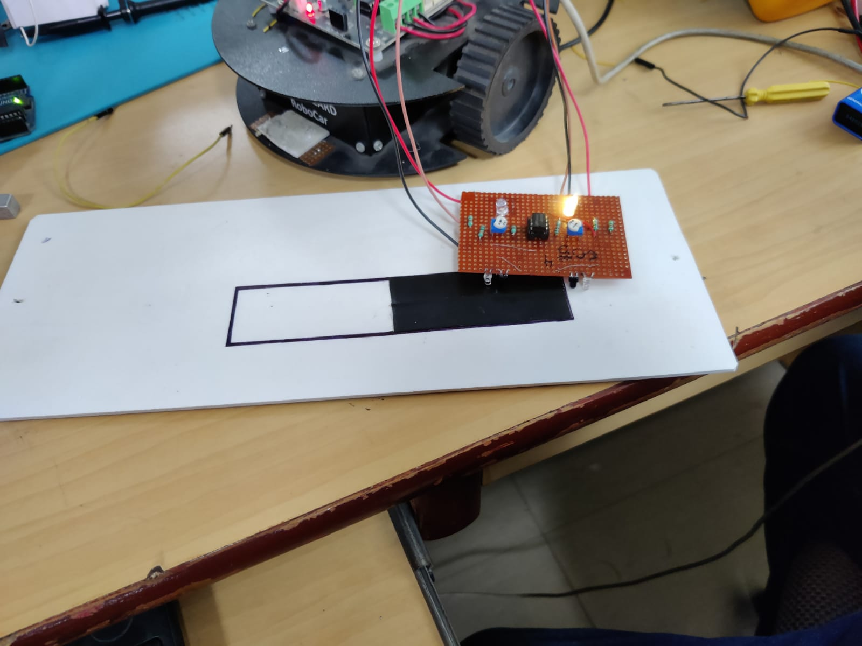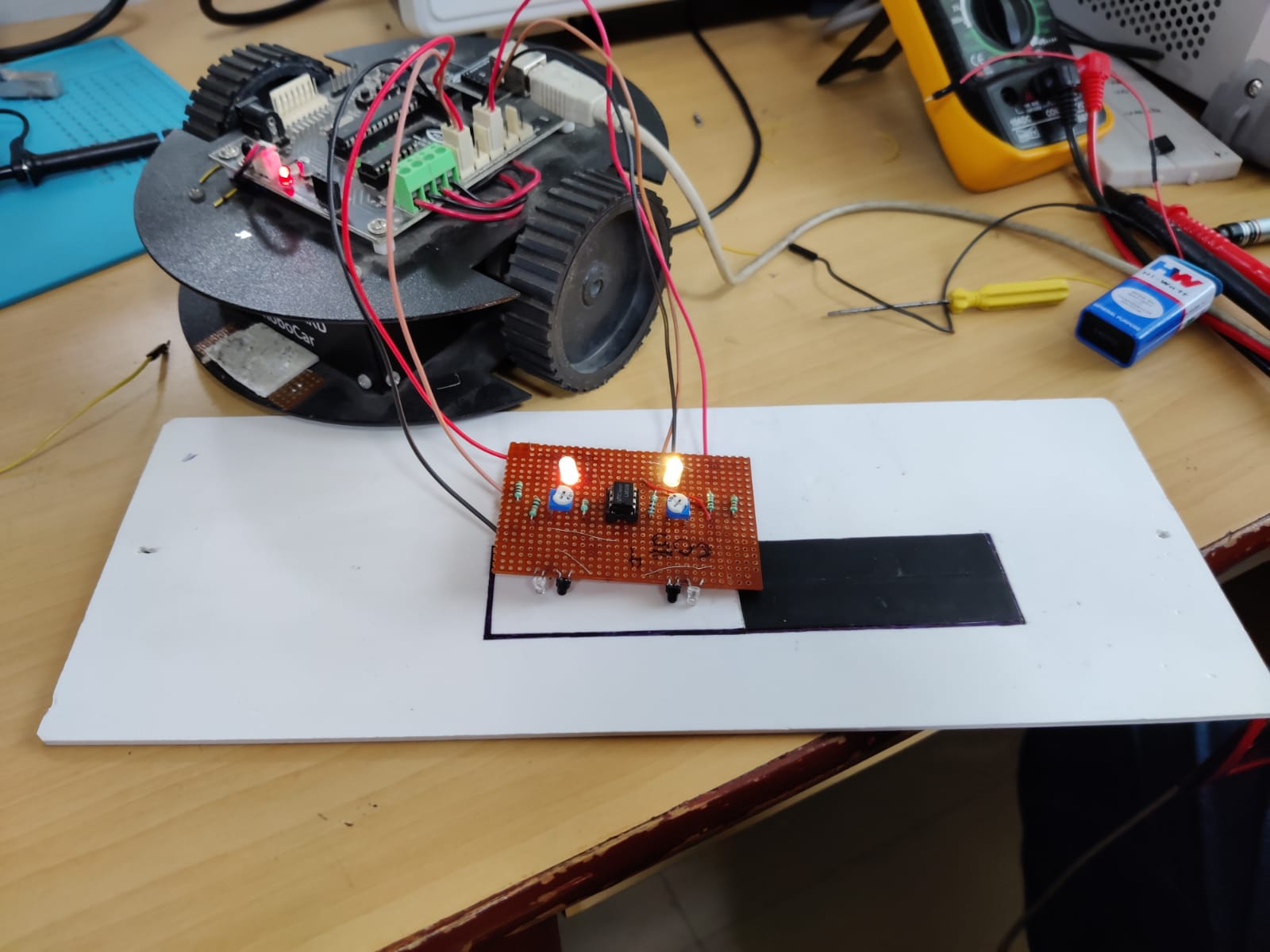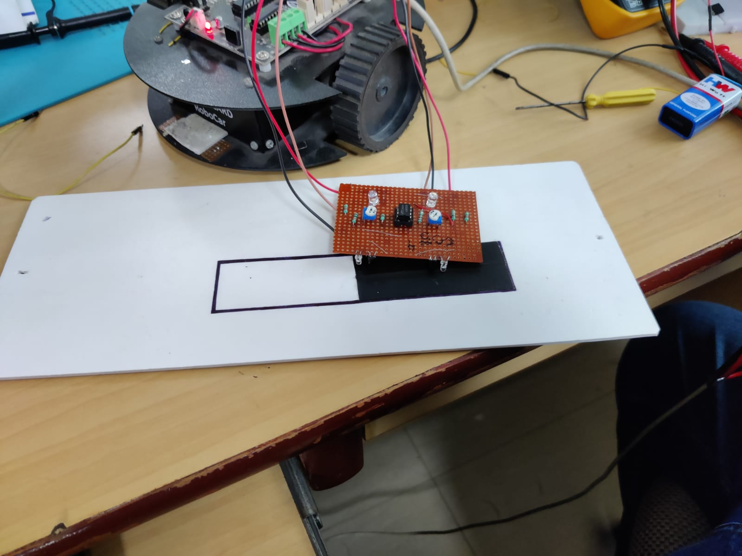

**Conclusion:**

In this experiment we learnt IR Sensor Module circuit which helps our buggy to move in a specified path